CHAPTER 5: Separating mixtures
Worksheet 5.2

Mailroom mayhem
Science Quest 7: pages 182–184
Student: Class:

Australia Post handles 19 million items of mail every day. Imagine you are in control of planning how the mail is separated into sensible groups for delivery. Try your skill as a mail separator by using the
16 sample mail items shown opposite.
1. Use the concept map started below to show how you will separate all the mail shown.

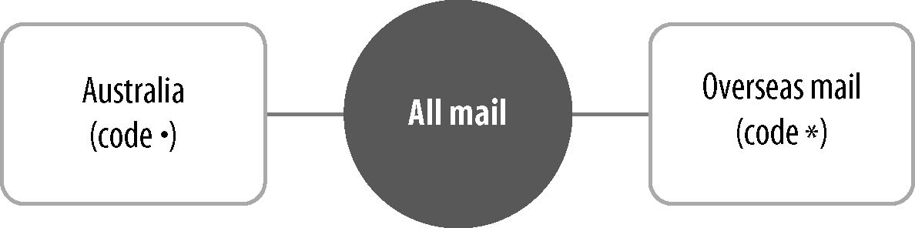

2. Give a code to each stage of your concept plan. Place this code against each mail piece to ensure you don’t miss anything.

3. How could a machine be programmed to help with mail separation?

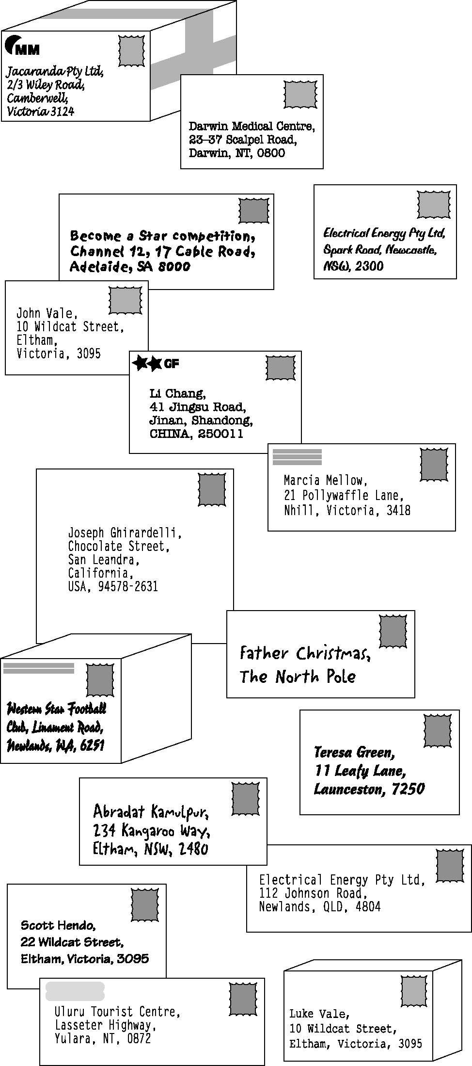

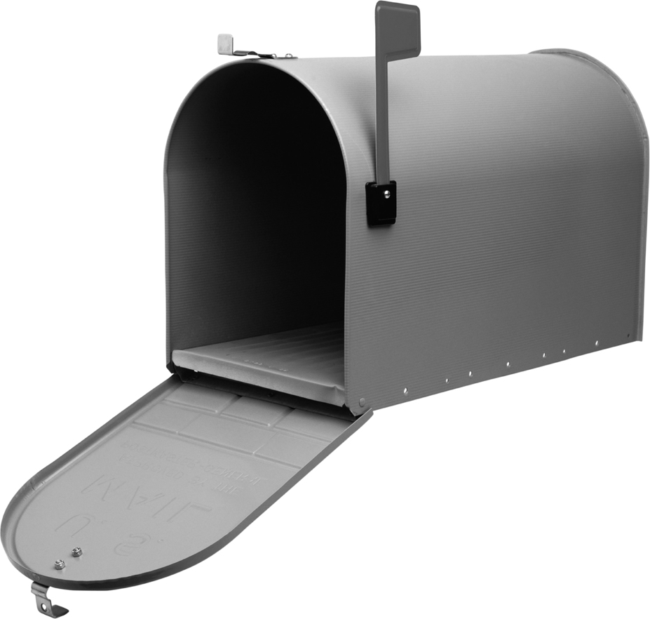
Source: Photodisc, Inc.

